# U3 - Practical Endorsements

## The Speed of a Stationary Wave

Set up the following equipment below:

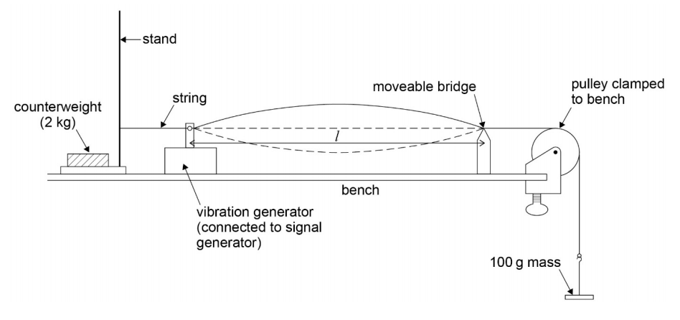

*A G-clamp can be used instead of a counterweight.*

And set up the following table:

|  |  |  |
| --- | --- | --- |
| l / m | f / Hz | T / s |
| ... |  | ... |
| ... |  | ... |

You should know the first harmonic is found at the fundamental frequency (f0). The fundamental frequency is the lowest frequency for a standing wave to form.

One thing that can be investigated is how length affects the fundamental frequency:

1. Move the bridge to different points to measure the length and the frequency (using the signal generator).
2. Work out the time period using f = 1/T for each length.
3. Draw a line of best fit of length (m) against time period (s).
4. With some rearranging and substitution, you can get a line of $l =\frac{cT}{2}$ where $\frac{c}{2}$ is the gradient, so multiply the gradient by 2.

Or you can measure the tension and mass per unit length with the equation:

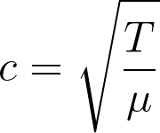

## Young’s Double Slit and Diffraction Gratings

* Do not look down the end of the lasers.
* Ensure the screen you’re shining on isn’t reflective.
* Rearrange the equations to find what to measure and what line to plot.

### Young’s Double Slit

* The setup of the experiment is shown below:

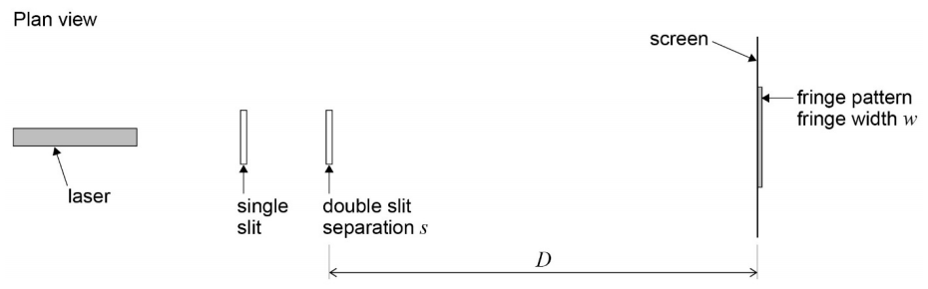

*The single slit isn’t need.*

### Diffraction Grating

* The setup of the experiment is shown below:

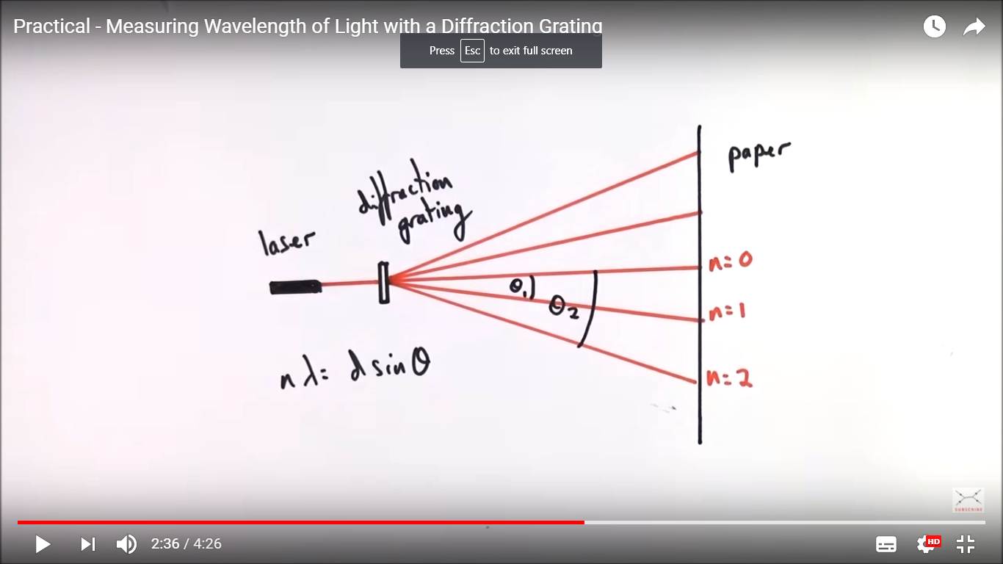

* You can measure the angle of each order using trigonometry and find several values of the wavelength before finding a mean wavelength.

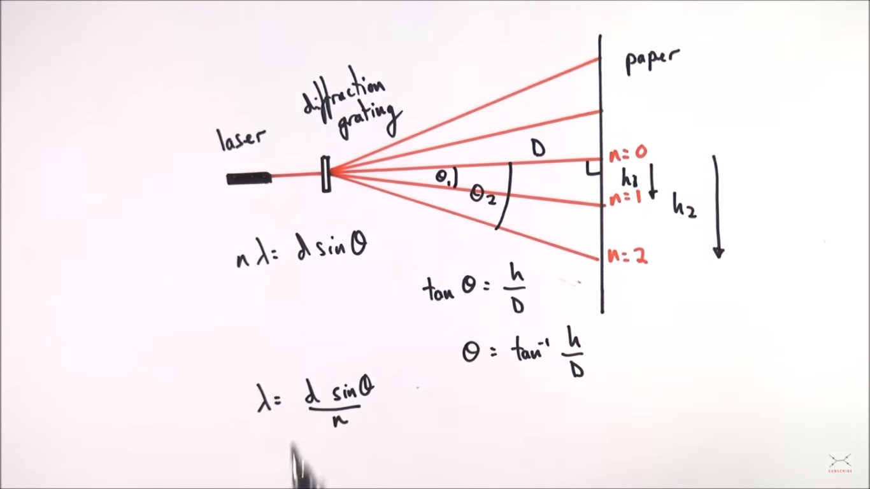

* You can improve the measurements by finding the angle between both n = 2 and halving it. This reduces the effect of the uncertainty when as a percentage. 30 ± 1° is better than 15 ± 1°.

# U4 - Practical Endorsements

* Use small masses to give more data points (before you exceed the limit of proportionality) but not so small that the percentage error increases.

## Measuring the Young Modulus of a Material

* Necking would occur near the end so ensure to take the gradient of the straight line graph.
* Measure the diameter of the wire thrice to get a mean diameter to use for area.
* The longer the wire, the more it extends for the same force and thus reduces the effect of the uncertainty
* Make measurements for and plot an extension-force graph as shown below:

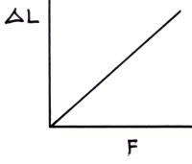

* You can then use the gradient in the equation below:

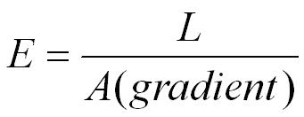

# U5 - Practical Endorsements

* Ensure physical conditions remain constant (e.g., temperature).

## Measuring the Resistivity of a Wire

* Measure the diameter along three different pairs of opposite sides.
* Record lengths using either a metre ruler or micrometre.
* Press down on the metal electrodes to improve contact and thus allow for a better reading.

## Calculating Electromotive Force and Internal Resistance

* Adjust the resistance on a variable resistor to adjust the current flowing through the circuit and the terminal p.d.
* Plot the voltages for each current and extrapolate backwards to get the y-intercept or measure the gradient for the internal resistance.
* Switch off the cell between readings to keep the emf as constant as possible.
* The y-intercept and the gradient are justified using the equation:

